
Hello Team Officials,
Updated Vendors & Food Bank Jan 26
Welcome to the 2nd Annual Georgina Golden Hawks Lake Simcoe Winter Classic being hosted by the Georgina Golden Hawks. Thank you for taking the time to come and celebrate a weekend of outstanding female hockey. We are grateful to see our returning teams who have over the past many years come from near and far to engage ours and other association teams in fair play, strong competition, and as always, friendships that know no borders in a true testament of our collective love of our game.

We are truly excited to announce that we have reached 40 Teams. Thank you for your support!

At this time of the year, may I on behalf of the Georgina Golden Hawks Executive team and members, wish everyone the happiest of holidays, Merry Christmas, and all the best in the 2026 New Year.

Andrea Filby
President, Georgina Golden Hawks



Tournament Information
- Tournament Headquarters: Georgina Ice Palace
- 2026 Tournament Schedule: Now available in the Documents Section of the main event page.
- Official Website: https://www2.sportacularevent.com/portal//events/event/119

- RULE#1 - All Teams will Register at your first game by producing your Official OWHA Approved Roster to the Convenor onsite. Hockey Canada and OWHA SUSPENSION rules shall apply where required. Any team using an OWHA Pickup Players must follow these rules of face Forfeiture and or Suspensions and fines. Teams may use the MAX 3 of 3 Players to Replace Existing players on their Official Roster. You can NOT Replace Suspended players. Rep teams may only use Players from BELOW LEVEL OF PLAY – No Lateral Callups even if playing up in a combined division. HL Teams are allowed to use lateral pickup players. Please note at no time can you NOT exceed the total # of players on your official Roster. The use of an official OWHA Pickup can only be accessed inside your teams RAMP acct, we are no longer are allowed to accept paper versions.

- If you find what you believe as an incorrect score, please notify us via email @ info@sportacularevents.com to help expedite inquiries. Please in subject line use: Game Concern - the division and GM# - then share your concern. Saturday is a very busy day for advancing teams. We have a process which identifies which divisions have to be advanced in a chronological process. Many inquiries are made and the pool or divisions has not completed their final RR games in order for us to calculate and advance teams. We appreciate everyone’s patience.
- Team Ramp Game Codes Schedule is now available see attached and it is posted in the Document section of the main page.

Team Roster Submission
- Official PDF Rosters MUST be uploaded to your Sportacular Events account.
- All out of province teams must provide their travel permits 10 days before
- Mandatory request for all teams - Log in to your Sportacular Event Acct, go to MY TEAMS, select your registered team, and click EDIT to update your roster and bench staff to ensure correct contact information is correct. Players only require jersey# and name.
- Yes, it needs to be manually typed in for the information below
- Be sure to save your updates to ensure accuracy for game sheets
- A single-page game sheet system is used for consistency between ice-level officials and administration.
- You may now also, as shown where to Upload your team’s official PDF roster.

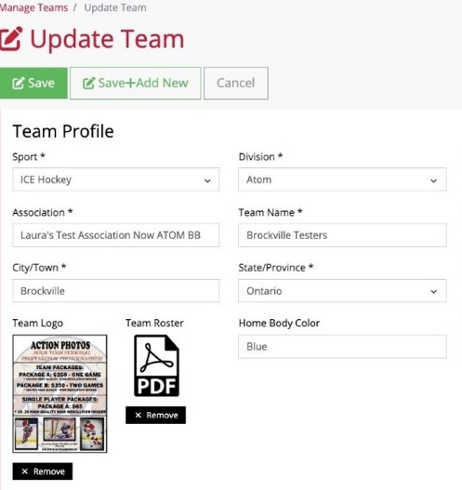
2026 Tournament Updates
- "Player of the Game" awards will be given for every game pickup at Arena Convenor Table in lobby you will sign for the award.
- Special Gold Medal Final both teams will get a “GOLD MEDAL Player of the Game”
- Championship Finals: Winners receive Gold Medals and an Arena Banner; finalists receive Silver Medals.
- New Awards: Same as Player of game awards, if a player has a Hat Trick or Shutout
  - "Wholly Moly Who's That Goalie" Shutout Awards
  - "Holy Hat Trick" Awards for players scoring a hat trick

Important Rules & Reminders
- Player Eligibility: Players can only compete with one team in one tournament during the weekend
- Pickup Players: Any team using an OWHA Pickup Players must follow these rules or face Forfeiture and or Suspensions and fines.
- Any team Found to be using an illegal player or playing suspended players will be removed from the tournament and any further games will results in Game Forfeitures. The OWHA Will also be notified as required
- Rep Teams: Allowed max 3 replacements but cannot replace suspended players. Rep teams may only use Players from below levels of play – No Lateral Callups even if playing up in a combined division. If a team has been found to use an illegal callup or player the team will be removed from the event
ALL Teams cannot exceed their official roster limit at any time.

- Equipment Rules:
- USA Teams: Mandatory mouthguards (per USA Hockey Insurance).
- Canadian Teams: Mandatory BNQ neck guards (per Hockey Canada)
- JERSEYS: Home and Away Jersey Colors Sect 17 of OWHA Handbook; Home Teams will wear Dark colored Jerseys and visitor teams will wear light. NOTE: for the 2025/26 Season Home teams have the Option to wear Light Colored Jerseys. If they choose to wear Light Colored as Home Team, they must notify visiting team once games are scheduled. We recommend to approach the other team when at the arena.
- Jersey Color Conflicts: House league LL teams should bring an extra set of jerseys or pinnies to avoid conflicts making a request to association watch for an email regarding HL Jerseys.
- Where needed only 1 team official will sign for POG awards prior to each game.
- Suspensions: Hockey Canada and OWHA SUSPENSION rules shall apply where required. All suspensions must be reported to OWHA via email and await their direction as to number of games. You must comply. Clearance must be received before returning to play. Teams from out of Province will be notified of IF a member of team is under suspension
- Rosters: Have a copy of your roster available in the event of any discrepancy
- Tournament Rules: Posted live on the Sportacular site. Please also note we do not use GF/GA we instead use the Tie Breaker Calculator chart in the document sections.

Game Day Procedures
- Championship Awards & Photos: Arena banners and medals will be awarded off the ice due to safety and City and Town insurance regulations
- Dressing Rooms:
  - Keep rooms clean before vacating.
- Game Start Times: Games may begin up to 20 minutes early based on arena convenor coordination
- Check-in Requirements: Team managers or head coaches must check in with arena convenor in lobby before each game. You do not need to check in a headquarters.
- Player of the Game Award: A player of the game AWARDS will be provided at the sign in table prior to the start of each game and awarded by the coach who will sign for the item
- Shutout/Hatrick Awards: Available at the convenor table at the end of your game
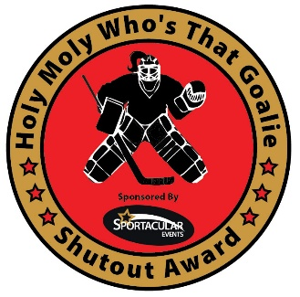
- Identifying Event Staff: Sportacular Event Staff will wear red jackets with “Event Staff on the bank. Ask for help at any game sheet sign-in area
- RAMP Game Codes: Will be emailed and also available at game sheet convenor tables.
- Your Team Ramp codes are included in the schedule. When you enter the codes for your games, each game will appear on your App. Please do this before the tournament to make sure your team information appears in the app and is correct.
- Your Team Manager and/or members of your bench staff must download and install the free Ramp Gamesheets App on your/their phone. Using the game ramp codes, you will be able to see your roster, sign-in, make roster changes, indicate if the player is playing, verify the score, etc.
- Attached is the Ramp Team information pdf for your review. Please have staff review it before your games to ensure you know how it works and what you need to do for the “non-paperwork” aspects of the tournament. If you have questions, there are email addresses inside the pdf for help.
- You will need to download the App for the tournament:
iPhone: https://apps.apple.com/ca/app/ramp-gamesheets/id1525405432
Playstore: https://play.google.com/store/apps/details?id=com.rampinteractive.gamesheets&hl=en_CA&gl=US&pli=1
- Step 1 download the app
Step 2 open App
Step 3 enter game code for game in question.
Step 4 click go to game
Tournament Vendors
- Moose Clothing Official Clothier – Georgina Ice Palace BR2 Printing Hoodies, Hats etc. KESWICK
- Authentic Photos Event Photographer KESWICK
- Skylar Baker - Georgina Ice Palace Blind Box Bonanza Sells Labubus, Slime, blind boxes, hockey cards etc KESWICK
- Mike Manahan - Georgina Ice Palace Cyclone Customs #D printed hockey keepsakes, team lightboxes, engraved tumblers etc. KESWICK
- Croc Charms – Croc Charms KESWICK
- Ms C's Freeze Dried Treats - Freeze Dried Candies. Friday ONLY KESWICK
- Lily the Unique and special Toy Lady – SUTTON ARENA
Skate Sharpening Info: Georgina Ice Palace all weekend

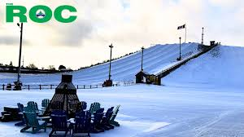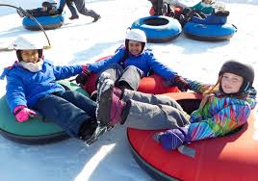
Dear Hockey Team Manager’s
Looking for a fun activity to keep your team energized and connected during your upcoming tournament?
The ROC offers the perfect opportunity for your players to unwind and enjoy the slopes during your visit to Georgina for the Lake Simcoe Winter Classic!
The ROC offers skiing, snowboarding, snow tubing and snowshoeing (rental equipment available onsite for a fee) - a great way to bond as a team, stay active, and create unforgettable memories.
All-access tickets are available online. The ROC offers group discounts for groups of 20 or more people (we suggest calling 905-476-8834 to book a large group.
You can easily reserve a time block of your choice by visiting our Rates and Reservations page.
Pre-registering ensures your team will have access to the slopes at your preferred time.
Don’t miss out on this exciting opportunity to add a little winter fun to your tournament schedule! If you have any questions or special requests, feel free to reach out—we’d be happy to help.
We look forward to hosting your team on the mountain!
Warm regards,
The ROC Admin Team
905-476-8834
georginaroc@georgina.ca


PHOTOGRAPHY PROGRAM- THE LAKE SIMCOE WINTER CLASSIC
MAIN LOCATION- GEORGINA ICE PALACE-(but rovers Shooters available by request)
1- ACTION PHOTOS- (BY REQUEST ONLY!
SAVE $100!!-PRE-BOOK EVENT SPECIAL-!!
FIRST 6 TEAMS TO BOOK AND PREPAY THE 2 GAME PACKAGE-
(REGULAR - $350 - SPECIAL- $250)
2-TEAM PHOTOS
"NEW TEAM PHOTO!!"
BOOK YOUR TEAM PHOTO APPOINTMENT
(No obligation to Purchase!)- DETAILS BELOW
NOTE- TEAM PHOTO IMAGE NOT INCLUDED IN ACTION PHOTO PACKAGE
TO BOOK- CONTACT
TEXT -ERIC- 416-579-1845 OR EMAIL
eric.niskanen@sympatico.ca
